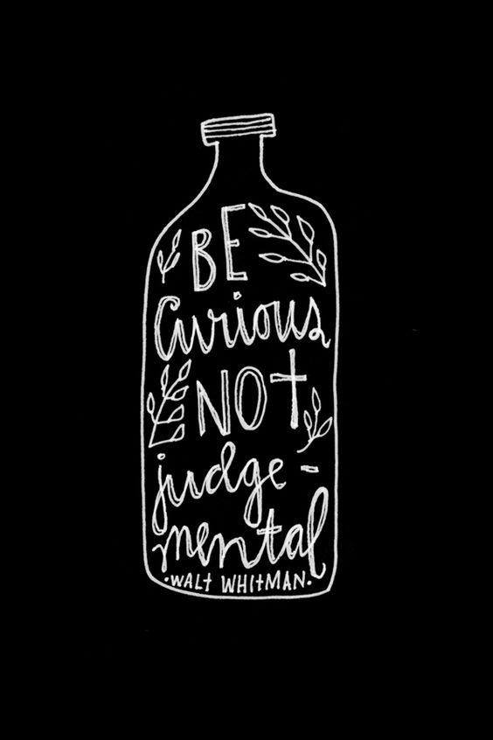
Curiousity - Family Faith Formation
Books/Readings of Memory
Stories to read together:

The Misadventures of the Family Fletcher (Family Fletcher Series)

by Dana Alison Levy (Author)

Parents:
I Wonder: Tools to Inspire Curiosity, Reflection, and Empathy in Kids
From the “Doing Good Together” website
https://www.doinggoodtogether.org/bhf/blog/i-wonder
Family Video

Peep and the Big Wild World (3 ten-minute episodes for Preschoolers)
https://www.youtube.com/watch?v=ZYkzNuEQhUs
Peep and the Big Wild World: A Peep of a Different Color
https://www.youtube.com/watch?v=zKdqzvQDtvM
Peep’s Moon Mission narrated by Joan Cusak
https://www.youtube.com/watch?v=gdj8lPvW0rc
Movie of Curiousity

Beauty and the Beast (2017)
Discussion/Activity:

Share Curiosity
Gather as a family before an evening meal. Have each member of the family name something they are curious about or something they learned that day. If you like, light candles as you share. Consider saying candle-lighting words that affirm asking questions, for example, "We give thanks for our curiosity and the answers it brings." Avoid editing or answering one another's questions, correcting information, or exchanging dialogue until everyone has shared. Where possible, provide resources and encourage family members to seek answers themselves. It is okay to validate questioning as a process that is as important, if not more important than, determining answers. (To keep this activity popular, avoid pressuring family members to do research every time a "wondering" is shared.)

